Conference Title (Do not change this in review)
Enhancing LSTM Stock Price Prediction for BBCA Using Broker Summary Features: A Deep Learning Experimental Study
Dave Andamitova Chuaª,Puti Andam Suriª,Muhammad Fajarª
ªComputer Science Department, School of Computer Science, Bina Nusantara University, Jakarta, Indonesia 11480

Abstract
Investing strategies has been challenging for most retail investor, and need to be optimized for institution quant firms due to market volatility and uniqueness of IHSG market dynamic. While there is a lot of machine learning and deep learning research propose respectable accuracy with dataset configuration of OHLCV and technical indicator. But there a gap in that no one use broker summary data to enhance their model. Therefore, this research propose solution for that gap by combining OHLCV, Broker summary for detecting institutional activity, and technical indicators. We compare four features configuration across LSTM and XGBoost using MAE, RMSE, and MAPE as our metrics for evaluation. We found out that LSTM with full three features combination resulting in best outcomes for LSTM model with MAPE of 2.08%, While XGBoost performs better with smaller datasets of OHLCV only at 1.76% MAPE. Adding Technical Indicator alone with OHLCV degraded model accuracy confirming redundancy without giving predicting value. However, when combined with broker summary data it served as mediator that provides better generalization for model resulting in best model.
Placeholder for copyright notice
Keywords: LSTM; XGBoost; broker summary; stock price prediction; BBCA; IDX; deep learning; ablation study;
- Introduction
Bank Central Asia is very well-known bank in Indonesia. The number of users keeps growing every year. Also, due to its gigantic market capitalization and strong liquidity in the IHSG. But there are volatility problems of investing in stocks, for example because of MSCI Issue IHSG suspended by trading halt twice. BBCA is one of the stocks that has a big outflow ​[1], [2]​.

This research is very relevant today because predicting the share prices of blue-chip businesses is crucial for us, retail investors. Other than that, company executives and market analysts are also looking forward to knowing this insight to manage risks for their business purposes in an era of growing economic globalization and market volatility ​[3], [4]​. But because of the unfavorable state of the stock market in IHSG, conventional analytical techniques like simple technical indicators and linear fundamental models are inadequate for identifying short to medium term price movements ​[5], [6]​.

LSTMs are deep learning that have been used recently in stocks predicting study ​[6]​. LSTMs function by identifying nonlinear patterns and long-term temporal correlations that are typically overlooked by humans or even by traditional machine learning algorithms ​[7]​. Although several studies have successfully applied LSTMs to historical price data (OHLC) ​[7], [8], [9], [10]​. It was difficult to adapt the model's sensitivity due to the uniqueness of IDX behavior ​[8], [9], [10]​. Broker summary, often referred to as "Money Flow"​[11]​. Correlated to the behavior of accumulation and distribution activities of institutional and retail investors are often the primary drivers of price fluctuations in Indonesian blue-chip stocks ​[11], [12]​.

This research aims to bridge this gap by developing an LSTM-based predictive model that accommodates Broker Summary features to enhance forecasting accuracy ​[13], [14]​. While conventional dataset only works in a normal environment. Our Broker summary dataset will catch patterns of the smart money move especially in small caps stocks ​[15]​. While money flow analysis is often associated with small caps of stocks, we choose BBCA to avoid stocks manipulations also to demonstrate the model robustness on high liquidity environments in which institutional money stays for long term. We evaluate the model’s performance using metrics including Mean Absolute Error (MAE), Root Mean Square Error (RMSE), and Mean Absolute Percentage Error (MAPE), comparing it against a baseline price-only model.
- Related Studies
One of the most often used investment products nowadays is stock ​[16]​. But the extreme volatility of stock prices frequently makes investors scared to make an investment decision ​[17]​. We discovered that to lower uncertainty and facilitate improved investment decision-making, accurate forecasting systems are required ​[18]​. Some papers determine that Machine Learning and Deep Learning algorithms are suitable to predict stock prices ​[19]​.

Riady explained in his research that Prophet by meta is good for analyzing time series data. His study examined time series data of OHLC with a focus on BBCA and TLKM shares ​[20]​. some standard statistical metrics were used to assess the Prophet model's ability. The results of low metrics indicate accuracy of the model ​[20]​. The model generated a Root RMSE of 49.6, MSE of 2462.1, and MAE of 37.5 for BBCA stock based on the assessment criteria ​[20]​.

LSTM networks were combined with CNN by Francis Magloire Peujio Fozap to capture both long term patterns and sudden short term price changes ​[21]​. He done backtest for his DL algorithm on the famous S&P 500 index [​[21]​. and the research highlighted an interesting trade off ​[21]​. He found that even though the traditional Random Forest model achieved the highest RMSE of 0.0859 ​[21]​. But this model doesn’t have the ability to understand the sequential nature of market events ​[21]​. But the hybrid model with an RMSE of 0.1012 and an MAE of 0.0800 seems to be less accurate, but it was more suited for real world trading due to its ability to understand market noises ​[21]​.

There is comparative analysis study of Indonesian banking stocks prices using Prophet, XGBOOST and ridge regression by Tony, Rachagit and Hiryanto. They use classic OHLC dataset from yfinance. From their research I discovered that ridge regression is the winner with very low number of MAE and RMSE indicating that the model was accurate. Surprisingly modern models like prophet outperformed by simple ridge regression [22].

- Research Methodology
We compare our current research with another related research based on target , and algorithm. We will compare our research with related to find our novelty ( see table 1)

Table 1 Comparision with previous research
Authors | Target Prediction | Datasets | Algorithm
Riady | BBCA & TLKM stock price (OHLC) | OHLCV | Prophet
Francis M. P. Fozap | S&P500 Stock price | - | CNN-LSTM, Random Forest
Tony et al. | Indonesian banking stock prices | OHLCV | Prophet, XGBoost, Ridge Regressions
This Research | BBCA.JK Closing Price | Broker Summary, OHLCV, Technical Indicators | Vanilla LSTM , XGBoost

3.1 Retrieving Datasets

We Retrieve this dataset from yfinance , there is some various features such as opening, highest, lowest, closing price and volume of BBCA.JK in terms of 2022 – 2025. The graph is provided in Fig 1. Also, we took some datasets from the securities website, such as a broker summary and some technical analysis index (in fig 2 and fig 3).

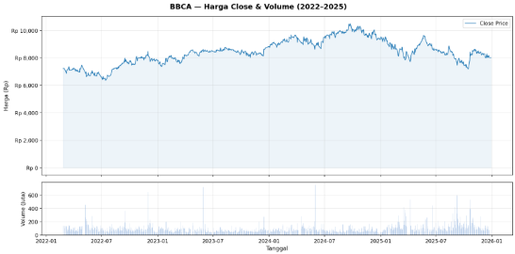
Fig 1 Closing Price and Volume of BBCA

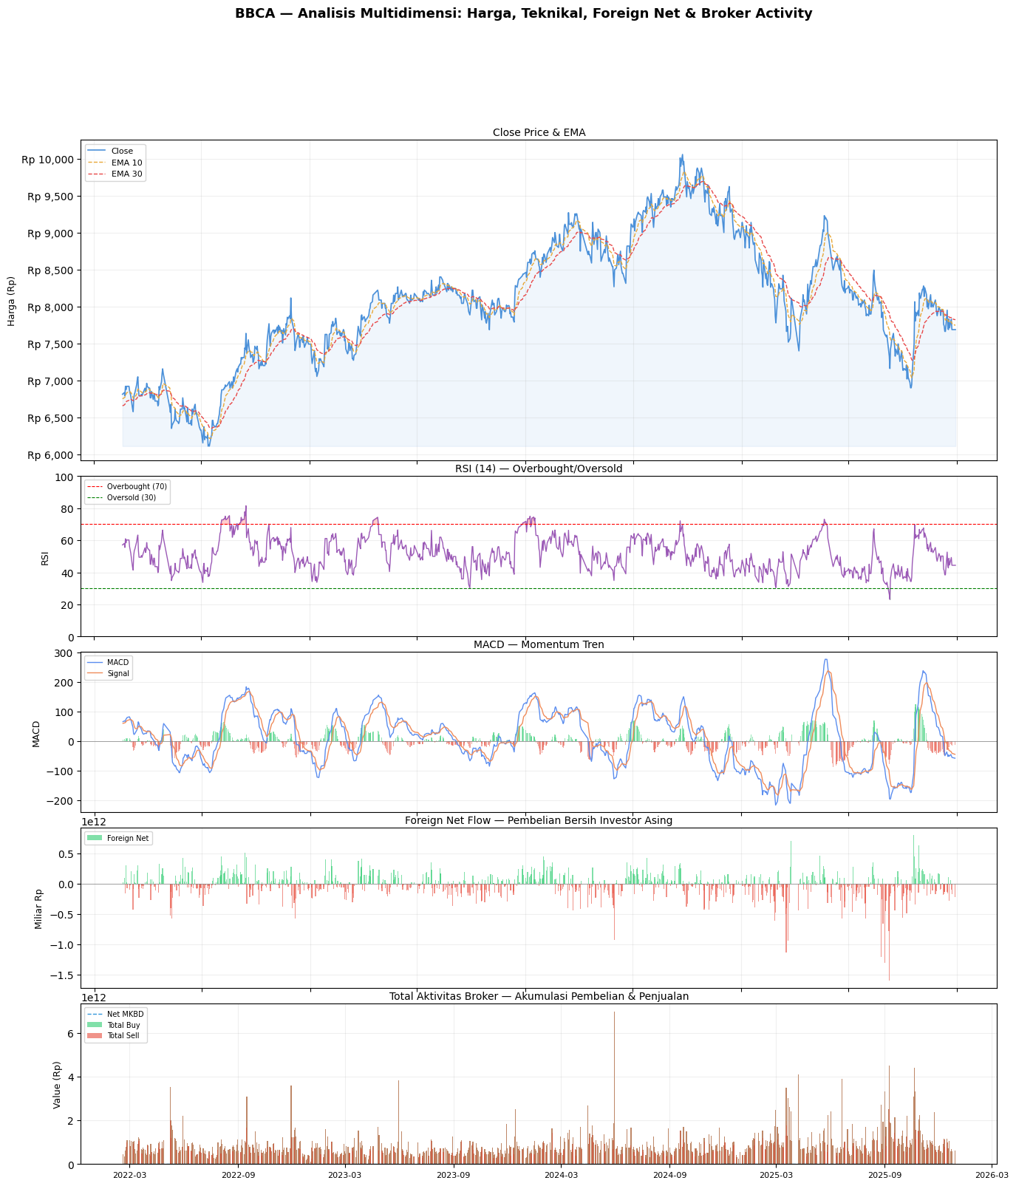
Fig 2 Technical Indicator of BBCA.JK and Foreign Flow

3.2 Dataset Preprocessing

From the dataset (see Fig 1 and Fig 2), we used 162 features including OHLCV prices, technical indicators, broker summary data, and foreign net flow for the modeling process. Then we split the data into three subsets: 70% for training, 15% for validation, and 15% for testing. All features were scaled using min-max normalization to the range of 0 to 1.

3.3 Training the models

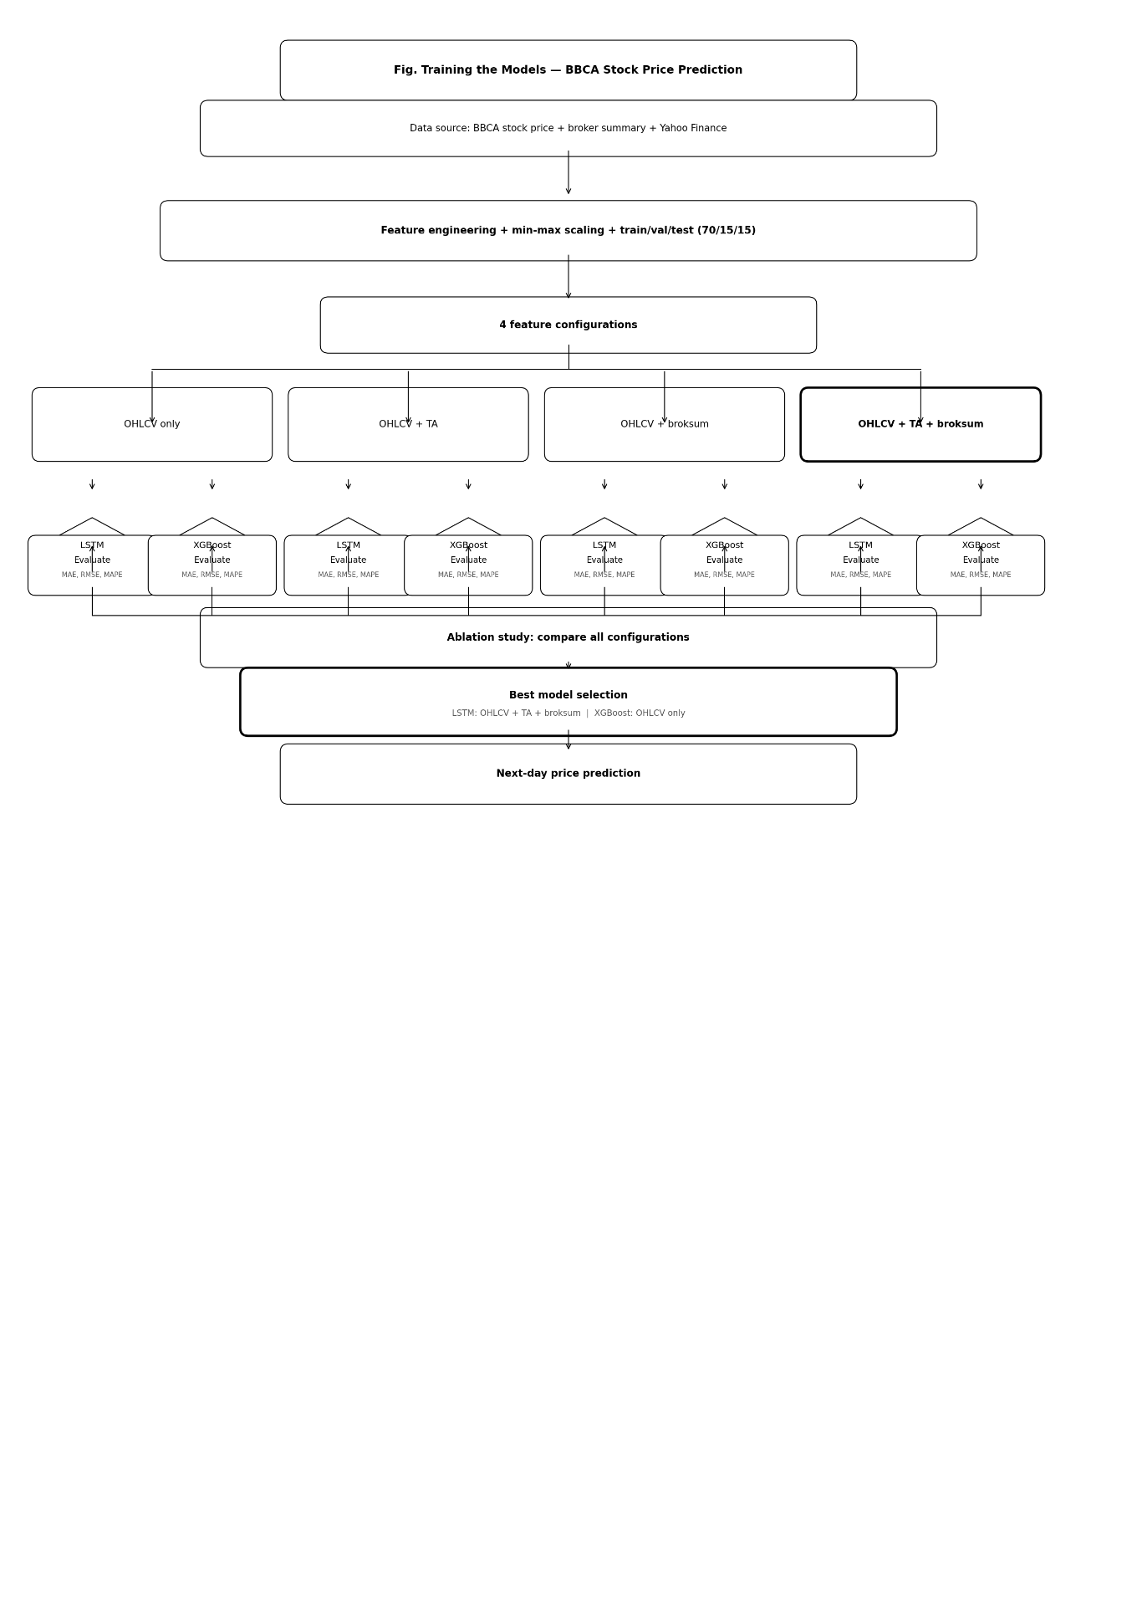

Fig 3 Our approach of predicting BBCA using LSTM and XGBOOST

Table 2 LSTM Parameters configuration
Layer | Number Of Units | Parameters
LSTM | 64 | 58,112
Dropout | - | 0
BatchNormalization | - | 256
LSTM_1 | 32 | 12,416
Dropout_1 | - | 0
BatchNormalization_1 | - | 128
Dense | 16 | 528
Dropout_2 | - | 0
Dense_1 | 1 | 17
Total parameters: 71,457
Trainable parameters: 71,265

Non – trainable Parameters: 192

Epoch: 200

Optimizer: Adam (LR = 0.01, ReduceLROnPlateAU min_LR = 1e-6)
4. Results and Discussions
Table 3 LSTM Results
LSTM | MAE (RP) | RMSE (RP) | MAPE (%)
OHLCV Only | Rp 200 | Rp 264 | 2.57 %
OHLC + TA | Rp 256 | Rp 296 | 3.15%
Broker summary + TA + OHLCV | Rp 167 | Rp 208 | 2.08%
Broker Summary + OHLCV | Rp 173 | Rp 225 | 2.15%

Table 4 XGBoost Results
XGBOOST | MAE (RP) | RMSE (RP) | MAPE (%)
OHLCV Only | Rp 136 | Rp 185 | 1.76 %
OHLC + TA | Rp 262 | Rp 305 | 3.26%
Broker summary + TA + OHLCV | Rp 161 | Rp 207 | 1.99%
Broker Summary + OHLCV | Rp 167 | Rp 232 | 2.03%

Both table 3 and 4 above reflects our experiments results. We found out LSTM demonstrate superior performance with conditions of more datasets (OHLCV, technical, broker summary) because when LSTM is given with small datasets, it accuracy often drop below expectation. But with broker summary data proves it ability to captures hidden pattern in BBCA.JK with respectable accuracy. In the other hands XGBoost slightly outperformed LSTM when only fed by OHLCV data. Because XGBoost is better than LSTM in a smaller dataset environment ​[23]​.
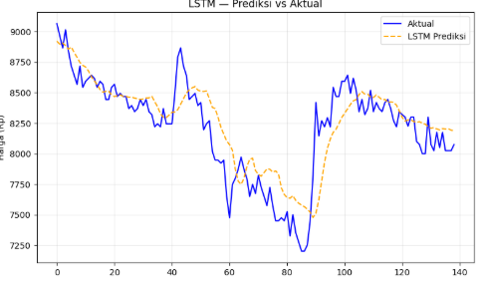

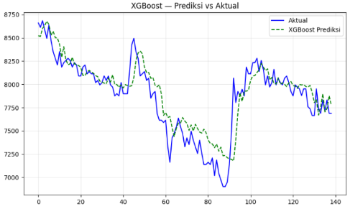
Fig 4 LSTM Broker Summary Forecast Graph

Fig 5 XGBoost OHLCV Only Forecast Graph

From both fig 4 and fig 5 we can take conclusion that LSTM is better with larger datasets that more suitable in the real quantitative finance industry. Also, when technical combined with OHLCV it becomes redundant because technical indicators are derived from price and volume which fed models with redundant datasets.

In the other hand when broker summary is combined with OHLCV there was slightly overfitting for LSTM model. This happened because LSTM memorizing broker summary activity without context, technical analysis tends to fix this because it helps better generalization and LSTM learns if specific broker is buying and the indicator was right then stocks are bullish. So, three of them combined resulting in the best features for LSTM.

- Conclusion
In conclusion, we successfully bridge the gap with broker summary features used on the LSTM model. We also figured out that OHLCV combined with technical indicators was redundant, leading to overfitting and lower accuracy. When OHLCV + broker summary only already had respectable accuracy. But with a broker summary it would be even better for LSTM; XGBoost on the other side performs better with smaller datasets such as OHLCV only.

There are limitations for this model such as only single stocks and limited timeframe of broker summary datasets. This pipeline is suitable for Indonesian stocks because of unique characteristics of broker summary that was not / partially available on another emerging / developed markets, both retail and institution investors. For future works this model can be extended to more blue-chip tickers whom the broker summary isn’t easy to manipulate.

ACKNOWLEDGEMENT

The authors would like to express gratitude to Puti Andam Suri and Muhammad Fajar for invaluable contributions to this research

Data Availability: The authors demonstrate commitment to data openness and transparency. To facilitate further research, we have made the data used in their study publicly available. The data used by the author can be opened via the

link: https://binusianorgmy.sharepoint.com/personal/dave_chua_binus_ac_id/_layouts/15/guestaccess.aspx?share=IQCmmgypKK-MSZsZwegjorM_ASi500583qWDb-KPw1XXSuk&e=Kbi5qm

Funding: This research project is funded by Bina Nusantara University. Declaration of Generative AI and AI-Assisted

Technologies: Generative AI tools (Gemini and/or Claude) were employed solely for paraphrasing and refining the text's clarity. The author(s) meticulously reviewed and edited the AI-assisted output to confirm its integrity, originality, and compliance with ethical standards. Verification checks confirmed that the proportion of plagiarized and AI-generated content was kept below the 20% threshold. The author(s) assume(s) full and absolute responsibility for the final content of this publication

https://binusianorg-my.sharepoint.com/:x:/r/personal/dave_chua_binus_ac_id/_layouts/15/guestaccess.aspx?share=IQCmmgypKK-MSZsZwegjorM_ASi500583qWDb-KPw1XXSuk&e=Kbi5qm

References

[1] H. S. Ganefi, W. J. Ermawati, and D. B. Hakim, "Market Structure, Income Diversity, and Stability: Empirical Study of Banking Industry Indonesia," J. Keuangan dan Perbankan, vol. 25, no. 3, pp. 701–716, Aug. 2021, doi: 10.26905/jkdp.v25i3.5887.
[2] A. S. B. Tarigan, P. Barasa, and C. F. Sitepu, "Economic Analysis of Initial Returns: The Impact of Stock Price, Offering Value, and Firm Age at Bank BCA (2020–2023)," Int. J. Econ. Dev. Res., vol. 6, no. 2, pp. 1019–1030, Apr. 2025, doi: 10.37385/ijedr.v6i2.7554.
[3] O. Guennioui, D. Chiadmi, and M. Amghar, "Global Stock Price Forecasting during a Period of Market Stress using LightGBM," Int. J. Comput. Digit. Syst., vol. 15, no. 1, pp. 19–27, Jan. 2024, doi: 10.12785/ijcds/150103.
[4] A. S. Toromade and N. R. Chiekezie, "Forecasting stock prices and market trends using historical data to aid investment decisions," Finance Account. Res. J., vol. 6, no. 8, pp. 1472–1484, Aug. 2024, doi: 10.51594/farj.v6i8.1434.
[5] D. I. Uhryn, Yu. O. Ushenko, Yu. Ya. Tomka, K. P. Hazdiuk, V. V. Dvorzhak, and D. A. Bilobrytskyi, "Agile risk management methodologies in the life cycle of an intelligent system for forecasting solutions of market share dynamics," Optoelectron. Inf.-Power Technol., vol. 49, no. 1, pp. 111–122, Jun. 2025, doi: 10.31649/1681-7893-2025-49-1-111-122.
[6] A. Y. Febriyanti, D. A. Prasetya, and T. Trimono, "Stock Price Prediction and Risk Estimation Using Hybrid CNN-LSTM and VaR-ECF," J. Tek. Inform. (Jutif), vol. 6, no. 3, pp. 1539–1554, Jun. 2025, doi: 10.52436/1.jutif.2025.6.3.4648.
[7] K. P. Raghuvanshi, A. B. Pande, N. S. Borchate, and R. S. Ingle, "A Systematic Literature Review on The Role of LSTM Networks in Capturing Temporal Dependencies in Data Mining Algorithms," Int. J. Res. Appl. Sci. Eng. Technol., vol. 12, 2024, doi: 10.22214/ijraset.2024.64761.
[8] A. Pathan, "Transformers Beyond Order: A Chaos-Markov-Gaussian Framework for Short-Term Sentiment Forecasting of Any Financial OHLC timeseries Data," arXiv:2506.17244, Jun. 2025. [Online]. Available: http://arxiv.org/abs/2506.17244
[9] S. Rathi, V. Khedkar, K. Naidu, B. Hake, S. Phapale, and V. Kulkarni, "Predicting Stock Market Trends Using Long Short-Term Memory (LSTM) Networks: A Deep Learning Approach for Financial Time-Series Forecasting," in Proc. Int. Conf. Smart Syst. Appl. Electr. Sci. (ICSSES), 2025, doi: 10.1109/ICSSES64899.2025.11009670.
[10] T. Fischer and C. Krauss, "Deep learning with long short-term memory networks for financial market predictions," Eur. J. Oper. Res., vol. 270, no. 2, pp. 654–669, Oct. 2018, doi: 10.1016/j.ejor.2017.11.054.
[11] D. P. Koesrindartoto, A. Aaron, I. Yusgiantoro, W. A. Dharma, and A. Arroisi, "Who moves the stock market in an emerging country – Institutional or retail investors?," Res. Int. Bus. Finance, vol. 51, p. 101061, Jan. 2020, doi: 10.1016/j.ribaf.2019.101061.
[12] M. Fahmi, G. Sonny, M. Kusuma, M. Faris Afif, and J. Widiyanti, "Peran Big Money dalam Pasar Modal Indonesia: Analisis Dampak terhadap Likuiditas, Harga Saham, dan Arah Sentimen Pasar," Balance: J. Akunt. dan Bisnis, vol. 10, no. 2, pp. 237–249, Nov. 2025, doi: 10.32502/balance.v10i2.989.
[13] D. K. Mohanty, A. K. Parida, and S. S. Khuntia, "Financial market prediction under deep learning framework using auto encoder and kernel extreme learning machine," Appl. Soft Comput., vol. 99, p. 106898, Feb. 2021, doi: 10.1016/j.asoc.2020.106898.
[14] M. Agrawal, P. K. Shukla, R. Nair, A. Nayyar, and M. Masud, "Stock Prediction Based on Technical Indicators Using Deep Learning Model," Comput. Mater. Contin., vol. 70, no. 1, pp. 287–304, Sep. 2021, doi: 10.32604/cmc.2022.014637.
[15] E. Zovinul, R. Rahila, N. Zukhri, and D. Altin, "Stock Broker Summary History Analysis Volume Value Frequency And Price Accumulation," in Proc. Int. Conf. Digit. Adv. Tourism Manag. Technol. (ICTMT), vol. 1, no. 2, pp. 369–376, Dec. 2023, doi: 10.56910/ictmt.v1i2.98.
[16] Pew Research Center, "More than half of U.S. households have investment in stock market," Mar. 2020. [Online]. Available: https://www.pewresearch.org/short-reads/2020/03/25/more-than-half-of-u-s-households-have-some-investment-in-the-stock-market/
[17] I. Prasodjo, Suyanto, D. Indiyati, and I. Atastina, "Enhancing Stock Forecasting and Investment Decisions with Stacking Ensemble on Historical Transaction Data," in Proc. Int. Conf. Inf. Commun. Technol. (ICoICT), 2025, doi: 10.1109/ICoICT66265.2025.11192904.
[18] A. S. Toromade and N. R. Chiekezie, "Forecasting stock prices and market trends using historical data to aid investment decisions," Finance Account. Res. J., vol. 6, no. 8, pp. 1472–1484, Aug. 2024, doi: 10.51594/farj.v6i8.1434.
[19] W. Jiang, "Applications of deep learning in stock market prediction: Recent progress," Expert Syst. Appl., vol. 184, p. 115537, Dec. 2021, doi: 10.1016/j.eswa.2021.115537.
[20] S. R. Riady, "Stock Price Prediction using Prophet Facebook Algorithm for BBCA and TLKM," Int. J. Adv. Data Inf. Syst., vol. 4, no. 1, pp. 1–8, Apr. 2023, doi: 10.25008/ijadis.v4i2.1258.
[21] D. Ahmed, F. Magloire, and P. Fozap, "Hybrid Machine Learning Models for Long-Term Stock Market Forecasting: Integrating Technical Indicators," J. Risk Financial Manag., vol. 18, no. 4, p. 201, Apr. 2025, doi: 10.3390/jrfm18040201.
[22] T. Tony, M. Ratchagit, and L. Hiryanto, "Forecasting Indonesian Banking Stock Prices Using Prophet, XGBoost, and Ridge Regression: A Comparative Analysis," J. Tek. Inform. (Jutif), vol. 6, no. 4, pp. 2890–2901, Sep. 2025, doi: 10.52436/1.JUTIF.2025.6.4.4973.
[23] E. Yu, H. Wei, Y. Han, P. Hu, and G. Xu, "Application of time series prediction techniques for coastal bridge engineering," Adv. Bridge Eng., vol. 2, no. 1, p. 6, Feb. 2021, doi: 10.1186/s43251-020-00025-4.

